Our Planet Earth

***What times passed by Earth?***

The History of Earth covers approximately 4 billion years, from Earth formation out of the solar nebula to the present. Earth formed as part of birth of the solar system what eventually became the solar system initially existed as a large, rotating cloud of dust and gas.

***What are the main composition of gases in Earth?***

The atmosphere is composed of a mix of several different gases in differing amounts. The permanent gases whose percentages do not change from day to day are nitrogen, oxygen and argon. Nitrogen accounts for 78% of the atmosphere, oxygen 21% and argon 0.9%. Gases like carbon dioxide, nitrous oxides, methane, and ozone are trace gases that account for about a tenth of one percent of the atmosphere. Water vapor is unique in that its concentration varies from 0-4% of the atmosphere depending on where you are and what time of the day it is. In the cold, dry artic regions water vapor usually accounts for less than 1% of the atmosphere, while in humid, tropical regions water vapor can account for almost 4% of the atmosphere. Water vapor content is very important in predicting weather(2)

***About Our home Planet Earth***

Earth is the third planet from the Sun and the only astronomical object known to harbor life. According to radiometric dating and other sources of evidence, Earth formed over 4.5 billion years ago. Earth's gravity interacts with other objects in space, especially the Sun and the Moon, Earth's only natural satellite. Earth orbits around the Sun in 365.26 days, a period known as an Earth year. During this time, Earth rotates about its axis about 366.26 times.

Earth's axis of rotation is tilted with respect to its orbital plane, producing seasons on Earth. The gravitational interaction between Earth and the Moon causes tides, stabilizes Earth's orientation on its axis and gradually slows its rotation. Earth is the densest planet in the Solar System and the largest and most massive of the four terrestrial planets.

Earth's lithosphere is divided into several rigid tectonic plates that migrate across the surface over many millions of years. About 71% of Earth's surface is covered with water, mostly by oceans. The remaining 29% is land consisting of continents and islands that together contain many lakes, rivers and other sources of water that contribute to the hydrosphere. The majority of Earth's polar regions are covered in ice, including the Antarctic ice sheet and the sea ice of the Arctic ice pack. Earth's interior remains active with a solid iron inner core, a liquid outer core that generates the Earth's magnetic field and a convecting mantle that drives plate tectonics.

Within the first billion years of Earth's history, life appeared in the oceans and began to affect the Earth's atmosphere and surface, leading to the proliferation of anaerobic and, later, aerobic organisms. Some geological evidence indicates that life may have arisen as early as 4.1 billion years ago. Since then, the combination of Earth's distance from the Sun, physical properties and geological history have allowed life to evolve and thrive. In the history of life on Earth, biodiversity has gone through long periods of expansion, occasionally punctuated by mass extinction events.ver 99% of all species that ever lived on Earth are extinct.

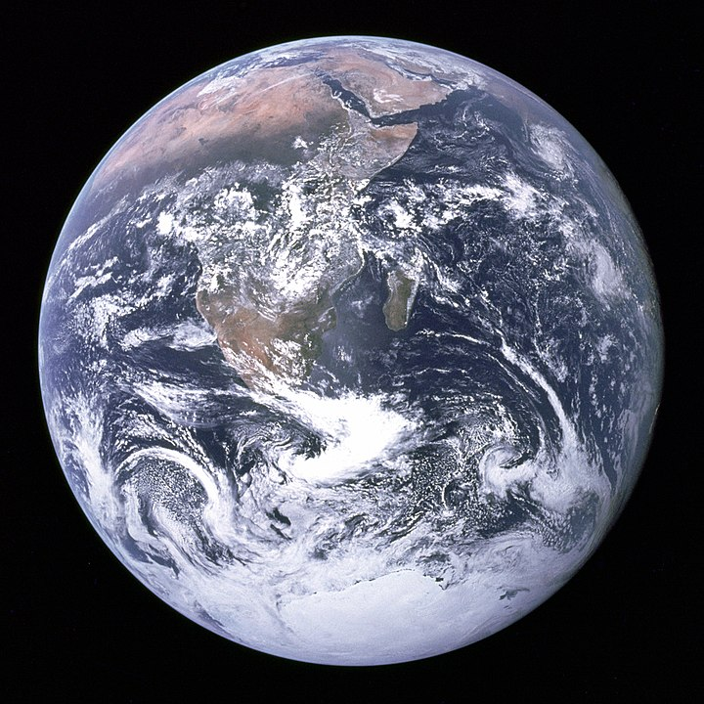

Fig: Our Home Planet Earth

The oldest material found in the Solar System is dated to 4.5672±0.0006 billion years ago (Bya). By 4.54±0.04 the primordial Earth had formed. The bodies in the Solar System formed and evolved with the Sun. In theory, a solar nebula partitions a volume out of a molecular cloud by gravitational collapse, which begins to spin and flatten into a circumstellar disk, and then the planets grow out of that disk with the Sun. A nebula contains gas, ice grains, and dust (including primordial nuclides). According to nebular theory, planetesimals formed by accretion, with the primordial Earth taking 10–20 million years (Mys) to form.

A subject of research is the formation of the Moon, some 4.53 Bya. A leading hypothesis is that it was formed by accretion from material loosed from Earth after a Mars-sized object, named Theia, hit Earth. In this view, the mass of Theia was approximately 10 percent of Earth, it hit Earth with a glancing blow and some of its mass merged with Earth. Between approximately 4.1 and 3.8 Bya, numerous asteroid impacts during the Late Heavy Bombardment caused significant changes to the greater surface environment of the Moon and, by inference, to that of Earth.

***Geological History of Earth***

Earth's atmosphere and oceans were formed by volcanic activity and outgassing. Water vapor from these sources condensed into the oceans, augmented by water and ice from asteroids, protoplanets, and comets. In this model, atmospheric "greenhouse gases" kept the oceans from freezing when the newly forming Sun had only 70% of its current luminosity. By 3.5 Bya, Earth's magnetic field was established, which helped prevent the atmosphere from being stripped away by the solar wind.

A crust formed when the molten outer layer of Earth cooled to form a solid. The two models that explain land mass propose either a steady growth to the present-day forms or, more likely, a rapid growth early in Earth history followed by a long-term steady continental area. Continents formed by plate tectonics, a process ultimately driven by the continuous loss of heat from Earth's interior. Over the period of hundreds of millions of years, the supercontinents have assembled and broken apart. Roughly 750 million years ago (Mya), one of the earliest known supercontinents, Rodinia, began to break apart. The continents later recombined to form Pannonia 600–540 Mya, then finally Pangaea, which also broke apart 180 Mya.

The present pattern of ice ages began about 40 Mya, and then intensified during the Pleistocene about 3 Mya. High-latitude regions have since undergone repeated cycles of glaciation and thaw, repeating about every 40,000–100,000 years. The last continental glaciation ended 10,000 years ago. The shape of Earth is nearly spherical. There is a small flattening at the poles and bulging around the equator due to Earth's rotation. To second order, the Earth is approximately an oblate spheroid, whose equatorial diameter is 43 kilometers (27 mi) larger than the pole-to-pole diameter,although the variation is less than 1% of the average radius of the Earth.

The point on the surface farthest from Earth's center of mass is the summit of the equatorial Chimborazo volcano in Ecuador (6,384.4 km (3,967.1 mi)).The average diameter of the reference spheroid is 12,742 kilometres (7,918 mi). Local topography deviates from this idealized spheroid, although on a global scale these deviations are small compared to Earth's radius: The maximum deviation of only 0.17% is at the Mariana Trench (10,911 metres (35,797 ft) below local sea level), whereas Mount Everest (8,848 metres (29,029 ft) above local sea level) represents a deviation of 0.14%.

***Chemical composition***

In geodesy, the exact shape that Earth's oceans would adopt in the absence of land and perturbations such as tides and winds is called the geoid. More precisely, the geoid is the surface of gravitational equipotential at mean sea level. Earth's mass is approximately 5.97×1024 kg (5,970 Yg). It is composed mostly of iron (32.1%), oxygen (30.1%), silicon (15.1%), magnesium (13.9%), sulphur (2.9%), nickel (1.8%), calcium (1.5%), and aluminum (1.4%), with the remaining 1.2% consisting of trace amounts of other elements. Due to mass segregation, the core region is estimated to be primarily composed of iron (88.8%), with smaller amounts of nickel (5.8%), sulphur (4.5%), and less than 1% trace elements.

The most common rock constituents of the crust are nearly all oxides: chlorine, sulphur, and fluorine are the important exceptions to this and their total amount in any rock is usually much less than 1%. Over 99% of the crust is composed of 11 oxides, principally silica, alumina, iron oxides.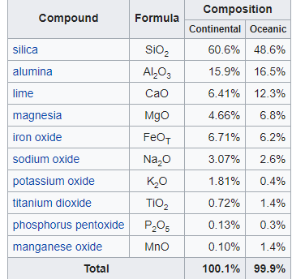

***Internal Structure***

Earth's interior, like that of the other terrestrial planets, is divided into layers by their chemical or physical (rheological) properties. The outer layer is a chemically distinct silicate solid crust, which is underlain by a highly viscous solid mantle. The crust is separated from the mantle by the Mohorovičić discontinuity. The thickness of the crust varies from about 6 kilometres (3.7 mi) under the oceans to 30–50 km (19–31 mi) for the continents. The crust and the cold, rigid, top of the upper mantle are collectively known as the lithosphere, and it is of the lithosphere that the tectonic plates are composed. Beneath the lithosphere is the asthenosphere, a relatively low-viscosity layer on which the lithosphere rides. Important changes in crystal structure within the mantle occur at 410 and 660 km (250 and 410 mi) below the surface, spanning a transition zone that separates the upper and lower mantle. Beneath the mantle, an extremely low viscosity liquid outer core lies above a solid inner core. The Earth's inner core might rotate at a slightly higher angular velocity than the remainder of the planet, advancing by 0.1–0.5° per year. The radius of the inner core is about one fifth of that of Earth.

|  |  |  |  |
| --- | --- | --- | --- |
| **Geologic layers of Earth** | | | |
| **[Earth cutaway schematic-en.svg](https://en.wikipedia.org/wiki/File:Earth_cutaway_schematic-en.svg)**  **Earth cutaway from core to exosphere. Not to scale.** | **Depth km** | **Component layer** | **Density g/cm3** |
| 0–60 | Lithosphere | — |
| 0–35 | Crust | 2.2–2.9 |
| 35–60 | Upper mantle | 3.4–4.4 |
| 35–2890 | Mantle | 3.4–5.6 |
| 100–700 | Asthenosphere | — |
| 2890–5100 | Outer core | 9.9–12.2 |
| 5100–6378 | Inner core | 12.8–13.1 |

***Surface of Earth***

The total surface area of Earth is about 510 million km2 (197 million sq mi). Of this, 70.8%,or 361.13 million km2 (139.43 million sq mi), is below sea level and covered by ocean water.Below the ocean's surface are much of the continental shelf, mountains, volcanoes, oceanic trenches, submarine canyons, oceanic plateaus, abyssal plains, and a globe-spanning mid-ocean ridge system. The remaining 29.2%, or 148.94 million km2 (57.51 million sq mi), not covered by water has terrain that varies greatly from place to place and consists of mountains, deserts, plains, plateaus, and other landforms. Tectonics and erosion, volcanic eruptions, flooding, weathering, glaciation, the growth of coral reefs, and meteorite impacts are among the processes that constantly reshape the Earth's surface over geological time.

The continental crust consists of lower density material such as the igneous rocks granite and andesite. Less common is basalt, a denser volcanic rock that is the primary constituent of the ocean floors. Sedimentary rock is formed from the accumulation of sediment that becomes buried and compacted together. Nearly 75% of the continental surfaces are covered by sedimentary rocks, although they form about 5% of the crust. The third form of rock material found on Earth is metamorphic rock, which is created from the transformation of pre-existing rock types through high pressures, high temperatures, or both. The most abundant silicate minerals on Earth's surface include quartz, feldspars, amphibole, mica, pyroxene and olivine. Common carbonate minerals include calcite (found in limestone) and dolomite.

The elevation of the land surface varies from the low point of −418 m (−1,371 ft) at the Dead Sea, to a maximum altitude of 8,848 m (29,029 ft) at the top of Mount Everest. The mean height of land above sea level is about 797 m (2,615 ft).

The pedosphere is the outermost layer of Earth's continental surface and is composed of soil and subject to soil formation processes. The total arable land is 10.9% of the land surface, with 1.3% being permanent cropland. Close to 40% of Earth's land surface is used for agriculture, or an estimated 16.7 million km2 (6.4 million sq mi) of cropland and 33.5 million km2 (12.9 million sq mi) of pastureland.

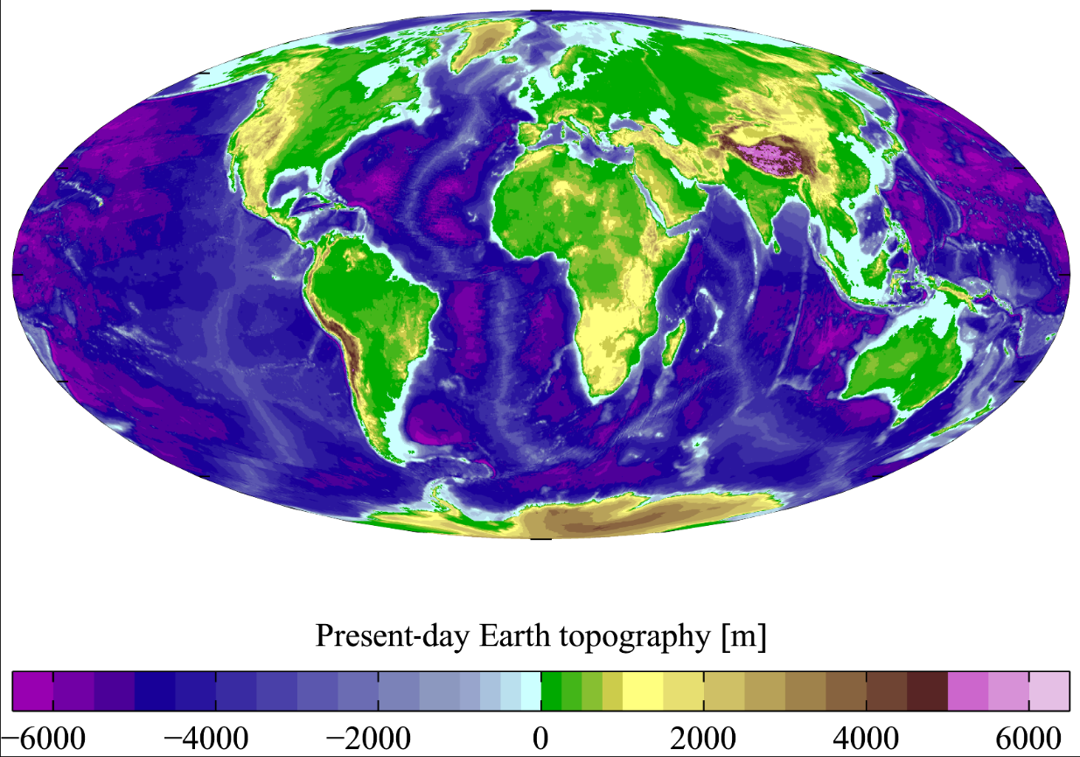

***Land creation history of Earth***

The earliest material found in the Solar System is dated to 4.5672±0.0006 bya (billion years ago);[3] therefore, the Earth itself must have been formed by accretion around this time. By 4.54±0.04 bya, the primordial Earth had formed. The formation and evolution of the Solar System bodies occurred in tandem with the Sun. In theory, a solar nebula partitions a volume out of a molecular cloud by gravitational collapse, which begins to spin and flatten into a circumstellar disc, which the planets then grow out of in tandem with the star. A nebula contains gas, ice grains and dust (including primordial nuclides). In nebular theory, planetesimals commence forming as particulate matter accrues by cohesive clumping and then by gravity. The assembly of the primordial Earth proceeded for 10–20 myr.

Earth's atmosphere and oceans were formed by volcanic activity and outgassing that included water vapor. The origin of the world's oceans was condensation augmented by water and ice delivered by asteroids, proto-planets, and comets. In this model, atmospheric "greenhouse gases" kept the oceans from freezing while the newly forming Sun was only at 70% luminosity.By 3.5 bya, the Earth's magnetic field was established, which helped prevent the atmosphere from being stripped away by the solar wind. The atmosphere and oceans of the Earth continuously shape the land by eroding and transporting solids on the surface.

The crust, which currently forms the Earth's land, was created when the molten outer layer of the planet Earth cooled to form a solid mass as the accumulated water vapor began to act in the atmosphere. Once land became capable of supporting life, biodiversity evolved over hundreds of million years, expanding continually except when punctuated by mass extinctions.

The two models that explain land mass propose either a steady growth to the present-day forms[or, more likely, a rapid growth early in Earth history followed by a long-term steady continental area. Continents formed by plate tectonics, a process ultimately driven by the continuous loss of heat from the Earth's interior. On time scales lasting hundreds of millions of years, the supercontinents have formed and broken apart three times. Roughly 750 mya (million years ago), one of the earliest known supercontinents, Rodinia, began to break apart. The continents later recombined to form Pannotia, 600–540 mya, then finally Pangaea, which also broke apart 180 mya.

***Area covered by land on Earth***

"Land area" (also known as "land mass") refers to the total surface area of the land of a geographical region or country (which may include discontinuous sections of land such as islands). Earth's total planimetric (flat) land area is approximately 148,939,063.133 km2 (57,505,693.767 sq mi) which is about 29.2% of its total surface. However, when terrain and topsoil relief are factored in, the actual topographic surface area – that exposed to the Sun, air and rain – is approximately quadrupled.Water covers approximately 70.8% of planimetric Earth's surface, mainly in the form of oceans and ice formations; but this proportion is decreased by the land's increased terrain.

"Land cover" is the physical material at the surface of the earth.

|  |  |  |  |  |  |  |  |
| --- | --- | --- | --- | --- | --- | --- | --- |
| **Land Cover in millions of hectar(million**[**ha**](https://en.wikipedia.org/wiki/Hectare)**= 10,000 km2)** | | | | | | | |
| [**FAO**](https://en.wikipedia.org/wiki/Food_and_Agriculture_Organization)**code** | **type**[[23]](https://en.wikipedia.org/wiki/Land#cite_note-23) | **1992** | **2001** | **2015** | **share in 2015** | **change from 1992** | **note** |
| [6970] | Artificial surfaces (including urban and associated areas) | 26.04 | 34.33 | 55.40 | 0.37% | 29.35 |  |
| [6971] | Herbaceous crops | 1,716.22 | 1,749.58 | 1,712.15 | 11.50% | −4.06 | [Arable land](https://en.wikipedia.org/wiki/Arable_land) |
| [6972] | Woody crops | 162.86 | 181.32 | 199.90 | 1.34% | 37.04 | Arable land |
| [6973] | Multiple or layered crops |  |  |  |  |  | Arable land |
| [6974] | Tree-covered areas | 4,434.92 | 4,393.70 | 4,335.00 | 29.11% | −99.93 | large decrease |
| [6975] | Mangroves | 18.06 | 18.39 | 18.74 | 0.13% | 0.67 |  |
| [6976] | Shrub-covered areas | 1,685.00 | 1,669.65 | 1,627.34 | 10.93% | −57.66 | large decrease |
| [6977] | Shrubs and/or herbaceous vegetation, aquatic or regularly flooded | 202.61 | 194.77 | 185.39 | 1.24% | −17.23 |  |
| [6978] | Sparsely natural vegetated areas | 891.78 | 878.69 | 868.07 | 5.83% | −23.71 |  |
| [6979] | Terrestrial barren land | 2,001.25 | 2,000.87 | 1,884.00 | 12.65% | −117.25 | large decrease |
| [6980] | Permanent snow and glaciers | 78.59 | 84.32 | 84.29 | 0.57% | 5.70 |  |
| [6981] | Inland water bodies | 432.60 | 435.00 | 444.57 | 2.98% | 11.97 |  |
| [6982] | Coastal water bodies and intertidal areas |  |  |  |  |  |  |
| [6983] | Grassland | 1,793.65 | 1,806.50 | 1,801.14 | 12.09% | 7.50 |  |
|  | **Total Land Mass** |  |  | **14,893.91\*** | **100%** |  |  |

Terrain and topsoil relief increase total land cover to approximately 64,000 million hectares (64 Gha) but proportions remain about the same.

***Land and climate relationship***

The land of the Earth interacts with and influences climate heavily since the surface of the land heats up and cools down faster than air or water. Latitude, elevation, topography, reflectivity, and land use all have varying effects. The latitude of the land will influence how much solar radiation reaches the surface. High latitudes receive less solar radiation than low latitudes. The height of the land is important in creating and transforming airflow and precipitation on Earth. Large landforms, such as mountain ranges, divert wind energy and make the air parcel less dense and able to hold less heat. As air rises, this cooling effect causes condensation and precipitation.

Reflectivity of the earth is called planetary albedo and the type of land cover that receives energy from the sun affects the amount of energy that is reflected or transferred to Earth. Vegetation has a relatively low albedo meaning that vegetated surfaces are good absorbers of the sun's energy. Forests have an albedo of 10–15% while grasslands have an albedo of 15–20%. In comparison, sandy deserts have an albedo of 25–40%.

Land use by humans also plays a role in the regional and global climate. Densely populated cities are warmer and create urban heat islands that have effects on the precipitation, cloud cover, and temperature of the region.(1)

Land products involve two related Global Change Master Directory (GCMD) disciplines. Land Surface includes geophysical processes and parameters involving the Earth’s land surfaces (e.g., surface temperature, soil moisture, vegetation cover, and land use). The Solid Earth discipline includes data sets related to processes arising in the Earth’s interior (e.g., gravity, geomagnetism, tectonics) which, although originating from below the surface, still can be analyzed from ground, air, or space-based measurements. Earth Observing System Data and Information System (EOSDIS) Distributed Active Archive Centers (DAACs) hold land surface and solid earth data sets, with some products overlapping other disciplines, such as frozen ground.(3)

***Water of Our home planet***

The Earth is a watery place. But just how much water exists on, in, and above our planet? About 71 percent of the Earth's surface is water-covered, and the [**oceans**](https://www.usgs.gov/special-topic/water-science-school/science/oceans-and-seas-water-cycle) hold about 96.5 percent of all Earth's water. Water also exists in the air as [**water vapor**](https://www.usgs.gov/special-topic/water-science-school/science/condensation-and-water-cycle), in [**rivers**](https://www.usgs.gov/special-topic/water-science-school/science/rivers-streams-and-creeks) and [**lakes**](https://www.usgs.gov/special-topic/water-science-school/science/lakes-and-reservoirs), in icecaps and [**glaciers**](https://www.usgs.gov/special-topic/water-science-school/science/glaciers-and-icecaps), in the ground as soil moisture and in [**aquifers**](https://www.usgs.gov/special-topic/water-science-school/science/aquifers-and-groundwater), and even in you and your dog.

Water is never sitting still. Thanks to the [**water cycle**](https://www.usgs.gov/special-topic/water-science-school/science/water-cycle), our planet's water supply is constantly moving from one place to another and from one form to another. Things would get pretty stale without the water cycle! (6)

Earth is known as the "Blue Planet" because 71 percent of the Earth's surface is covered with water. Water also exists below land surface and as water vapor in the air. Water is a finite source. The bottled water that is consumed today might possibly be the same water that once trickled down the back of a wooly mammoth. The Earth is a closed system, meaning that very little matter, including water, ever leaves or enters the atmosphere; the water that was here billions of years ago is still here now. But, the Earth cleans and replenishes the water supply through the hydrologic cycle.

The earth has an abundance of water, but unfortunately, only a small percentage (about 0.3 percent), is even usable by humans. The other 99.7 percent is in the oceans, soils, icecaps, and floating in the atmosphere. Still, much of the 0.3 percent that is useable is unattainable. Most of the water used by humans comes from rivers. The visible bodies of water are referred to as surface water. The majority of fresh water is actually found underground as soil moisture and in aquifers. Groundwater can feed the streams, which is why a river can keep flowing even when there has been no precipitation. Humans can use both ground and surface water. (4)

***Distribution of Earth water***

Ocean water: 97.2 percent

Glaciers and other ice: 2.15 percent

Groundwater,: 0.61 percent

Fresh water lakes: 0.009 percent

Inland seas: 0.008 percent

Soil Moisture: 0.005 percent

Atmosphere: 0.001 percent

Rivers: 0.0001 percent.(5)

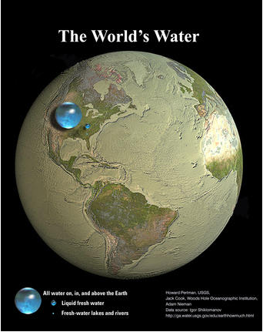

How much water is there on (and in) the Earth? Here are some numbers you can think about:

If all of Earth's water (oceans, icecaps and glaciers, lakes, rivers, groundwater, and water in the atmosphere was put into a sphere, then the diameter of that water ball would be about 860 miles (about 1,385 kilometers), a bit more than the distance between Salt Lake City, Utah to Topeka, Kansas. The volume of all water would be about 332.5 million cubic miles (mi3), or 1,386 million cubic kilometers (km3). A cubic mile of water equals more than 1.1 trillion gallons. A cubic kilometer of water equals about 264 billion gallons (999 billion liters).

About 3,100 mi3 (12,900 km3) of water, mostly in the form of water vapor, is in the atmosphere at any one time. If it all fell as precipitation at once, the Earth would be covered with only about 1 inch of water.

The 48 contiguous (lower 48 states) United States receives a total volume of about 4 mi3 (17.7 km3) of precipitation each day.

Each day, 280 mi3 (1,170 km3) of water evaporate or transpire into the atmosphere.

If all of the world's water was poured on the contiguous United States, it would cover the land to a depth of about 107 miles (145 kilometers).

Of the freshwater on Earth, much more is stored in the ground than is available in rivers and lakes. More than 2,000,000 mi3 (8,400,000 km3) of freshwater is stored in the Earth, most within one-half mile of the surface. But, if you really want to find freshwater, most is stored in the 7,000,000 mi3 (29,200,000 km3) of water found in glaciers and icecaps, mainly in the polar regions and in Greenland.

***Air of our home Planet Earth***

The atmosphere of Earth is the layer of gases, commonly known as air, that surrounds the planet Earth and is retained by Earth's gravity. The atmosphere of Earth protects life on Earth by creating pressure allowing for liquid water to exist on the Earth's surface, absorbing ultraviolet solar radiation, warming the surface through heat retention (greenhouse effect), and reducing temperature extremes between day and night (the diurnal temperature variation).

By volume, dry air contains 78.09% nitrogen, 20.95% oxygen, 0.93% argon, 0.04% carbon dioxide, and small amounts of other gases. Air also contains a variable amount of water vapor, on average around 1% at sea level, and 0.4% over the entire atmosphere. Air composition, temperature, and atmospheric pressure vary with altitude, and air suitable for use in photosynthesis by terrestrial plants and breathing of terrestrial animals is found only in Earth's troposphere and in artificial atmospheres.

The atmosphere has a mass of about 5.15×1018 kg, three quarters of which is within about 11 km (6.8 mi; 36,000 ft) of the surface. The atmosphere becomes thinner and thinner with increasing altitude, with no definite boundary between the atmosphere and outer space. The Kármán line, at 100 km (62 mi), or 1.57% of Earth's radius, is often used as the border between the atmosphere and outer space. Atmospheric effects become noticeable during atmospheric reentry of spacecraft at an altitude of around 120 km (75 mi). Several layers can be distinguished in the atmosphere, based on characteristics such as temperature and composition.

The study of Earth's atmosphere and its processes is called atmospheric science (aerology). Early pioneers in the field include Léon Teisserenc de Bort and Richard Assmann.

The three major constituents of Earth's atmosphere are nitrogen, oxygen, and argon. Water vapor accounts for roughly 0.25% of the atmosphere by mass. The concentration of water vapor (a greenhouse gas) varies significantly from around 10 ppm by volume in the coldest portions of the atmosphere to as much as 5% by volume in hot, humid air masses, and concentrations of other atmospheric gases are typically quoted in terms of dry air (without water vapor). The remaining gases are often referred to as trace gases, among which are the greenhouse gases, principally carbon dioxide, methane, nitrous oxide, and ozone. Besides argon, already mentioned, other noble gases, neon, helium, krypton, and xenon are also present. Filtered air includes trace amounts of many other chemical compounds. Many substances of natural origin may be present in locally and seasonally variable small amounts as aerosols in an unfiltered air sample, including dust of mineral and organic composition, pollen and spores, sea spray, and volcanic ash. Various industrial pollutants also may be present as gases or aerosols, such as chlorine (elemental or in compounds), fluorine compounds and elemental mercury vapor. Sulfur compounds such as hydrogen sulfide and sulfur dioxide (SO2) may be derived from natural sources or from industrial air pollution.

In general, air pressure and density decrease with altitude in the atmosphere. However, temperature has a more complicated profile with altitude, and may remain relatively constant or even increase with altitude in some regions (see the temperature section, below). Because the general pattern of the temperature/altitude profile, or lapse rate, is constant and measurable by means of instrumented balloon soundings, the temperature behavior provides a useful metric to distinguish atmospheric layers. In this way, Earth's atmosphere can be divided (called atmospheric stratification) into five main layers. Excluding the exosphere, the atmosphere has four primary layers, which are the troposphere, stratosphere, mesosphere, and thermosphere. From highest to lowest, the five main layers are:

Exosphere: 700 to 10,000 km (440 to 6,200 miles)

Thermosphere: 80 to 700 km (50 to 440 miles)

Mesosphere: 50 to 80 km (31 to 50 miles)

Stratosphere: 12 to 50 km (7 to 31 miles)

Troposphere: 0 to 12 km (0 to 7 miles)

Atmosphere discipline data sets focus primarily on characterizing the Earth’s troposphere and stratosphere. Within those layers occur many geophysical processes involving clouds, aerosols, precipitation, lightning, chemistry, temperature, radiation balance, and dynamics. Interactions of the atmosphere with land and ocean surfaces, and with solar radiation also fall within this discipline. NASA's Earth Observing System Data and Information System (EOSDIS) Distributed Active Archive Centers (DAACs) hold atmosphere data sets,

***Living Beings Of Earth***

In terms of diversity, there are more than 1.5 million species of plants, animals, fungi, lichen, and bacteria documented on Earth. And we are discovering more species every day! In terms of mass, there are currently about 75 billion tons of living things (biomass) on Earth. Jan 11, 2007

3.5 billion years ago earliest life form,

The age of the Earth is about 4.54 billion years; the earliest undisputed evidence of life on Earth dates from at least 3.5 billion years ago. There is evidence that life began much earlier.

Recent figures indicate that there are more than 1.4 billion insects for each human on the planet An article in The New York Times claimed that the world holds 300 pounds of insects for every pound of humans. Ants have colonised almost every landmass on Earth. More than 99% of all species of life forms, amounting to over five billion species, which ever lived on Earth are estimated to be extinct. Although the number of Earth's catalogued species of lifeforms is between 1.2 million and 2 million, the total number of species in the planet is uncertain. Conceptually, biogenesis is primarily attributed to Louis Pasteur and encompasses the belief that complex living things come only from other living things, by means of reproduction. That is, life does not spontaneously arise from non-living material, which was the position held by spontaneous generation. Human uses of living things, including animals plants, fungi, and microbes, take many forms, both practical, such as the production of food and clothing, and symbolic, as in art, mythology, and religion. The skills and practices involved are transmitted by human culture through social learning.

Ferns first appear in the fossil record about 360 million years ago in the late Devonian period. According to this system, the tree of life consists of three domains: Archaea, Bacteria, and Eukarya. The first two are all prokaryotic microorganisms, or single-celled organisms whose cells have no nucleus. The earliest fossils of anatomically modern humans are from the Middle Paleolithic, about 200,000 years ago such as the Omo remains of Ethiopia and the fossils of Herto sometimes classified as Homo sapiens idaltu. A "minimalist" approach to human taxonomy recognizes at most three species, Homo habilis (2.1–1.5 Mya, membership in Homo questionable), Homo erectus (1.8–0.1 Mya, including the majority of the age of the genus, and the majority of archaic varieties as subspecies, including H. heidelbergensis as a late or transitional.

***Future aspects of Earth***

Earth's expected long-term future is tied to that of the Sun. Over the next 1.1 Bys, solar luminosity will increase by 10%, and over the next 3.5 Bys by 40%. The Earth's increasing surface temperature will accelerate the inorganic carbon cycle, reducing CO2

concentration to levels lethally low for plants (10 ppm for C4 photosynthesis) in approximately 100–900 Mys.[88][89] The lack of vegetation will result in the loss of oxygen in the atmosphere, making animal life impossible.[90] About a billion years from now, all surface water will have disappeared and the mean global temperature will reach 70 °C (158 °F).The Earth is expected to be habitable until the end of photosynthesis about 500 Ma from now,[88] but if nitrogen is removed from the atmosphere, life may continue until a runaway greenhouse effect occurs 2.3 Ga from now. Anthropogenic emissions are "probably insufficient" to cause a runaway greenhouse at current solar luminosity.Even if the Sun were eternal and stable, 27% of the water in the modern oceans will descend to the mantle in one billion years, due to reduced steam venting from mid-ocean ridges.

The Sun will evolve to become a red giant in about 5 Bys. Models predict that the Sun will expand to roughly 1 AU (150 million km; 93 million mi), about 250 times its present radius.[87][94] Earth's fate is less clear. As a red giant, the Sun will lose roughly 30% of its mass, so, without tidal effects, Earth will move to an orbit 1.7 AU (250 million km; 160 million mi) from the Sun when the star reaches its maximum radius. Most, if not all, remaining life will be destroyed by the Sun's increased luminosity (peaking at about 5,000 times its present level). A 2008 simulation indicates that Earth's orbit will eventually decay due to tidal effects and drag, causing it to enter the Sun's atmosphere and be vaporized.

References

1. <https://en.wikipedia.org/wiki/Earth>
2. <https://climate.ncsu.edu/edu/Composition>
3. <https://earthdata.nasa.gov/learn/discipline/land>
4. <https://www.ngwa.org/what-is-groundwater/About-groundwater/information-on-earths-water>
5. <http://ga.water.usgs.gov/edu/earthwherewater.html>)
6. <https://www.usgs.gov/special-topic/water-science-school/science/how-much-water-there-earth?qt-science_center_objects=0#qt-science_center_objects>